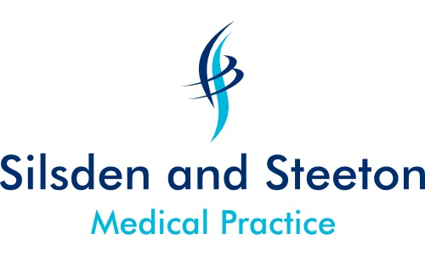

From Dr Jhaj
Hi all,
Silsden & Steeton Medical Practice are pleased to invite you to join our practice team. 2 salaried roles are available with partnership opportunity for the right candidate. Please see the attached document for more details. If you’re interested we’d love to hear from you. If not, apologies for the bulk email.

Imagine a practice where an ANP does at least 50% of the home visits on any given day, where practice pharmacists deal with the vast majority of repeat reauthorising, acute requests, outpatient medication requests & TTO reconciliation & where a trained clinical admin team sift & action your letters for you leaving you with very few letters to deal with each day.

2x SALARIED GP VACANCIES

With PARTNERSHIP opportunity for the right candidate

1x 6-8 session role (Partnership or salaried)
1x 4-6 session role (Salaried)

Exact Work Pattern/Days to be discussed at interview

Are you fresh out of training and looking for an exciting opportunity with an ambitious, forward thinking Practice?
Or are you an established GP looking for a new challenge in a friendly and professionally rewarding environment?
Maybe you’re an ambitious salaried GP looking for the right opportunity to go into partnership?
Perhaps you have a special clinical interest you wish to develop in the right environment?
Or perhaps you just want to work in a state of the art, new and purpose built facility, with a hardworking and loyal team of colleagues, in a semi rural location?

Whatever your motivation, GP retirement and Practice expansion has created 2 truly excellent opportunities at Silsden and Steeton Medical Practice.

- We have 11,000+ patients and increasing all the time;
- We are a 4 partner Practice, operating from 2 sites, with a strong and highly capable clinical and non clinical support team including GPs, ANPs, nurses, phlebotomist, on-site community matron, district nurses, health visitors, podiatrists, physiotherapists, counsellors and pharmacists;
- Our pharmacists provide daily support for repeat medication reauthorisation, managing acute medication requests, reconciling discharge medicines and outpatient requests – enabling you to focus on the core of the role.
- A dedicated reception team, with a separate trained and skilled admin team whose roles include filtering and actioning of incoming documents;
- Secretarial support and a strong and experienced management team;
- We are an established GP Training Practice, offering opportunities to Apprentices, FY2’s and Registrars;
- We are actively involved in Minor Surgery, Diabetes, Collaborative Care, Family Planning and Going for Gold palliative care and are a QOF high achiever;
- We have an active Patient Participation Group and are members of the Yordales Federation of GP Practices
- We use SystmOne;
- We offer 6 weeks annual leave per annum, plus study & training days, NHS pension and a competitive salary;

Still unsure whether such a great opportunity is for you? Why not give us a call on 01535 651828 or arrange to come in for a chat with a GP Partner or member of the management team to find out more and check out our facilities.

Closing Date: 18TH December
Interviews: early January.

Apply on-line at NHS Jobs or send your CV and covering letter to Mark Dixon, Head of Operations and Business Development, Silsden and Steeton Medical Practice, Elliott Street, Silsden, BD20 ODG or email mark.dixon@bradford.nhs.uk . Please advise us on the covering letter for which role you are applying and whether you would like to be considered for partnership so that appropriate interview preparations can be made.

